

NYSE opening bell

RECENT POSTS

November 30, 2011 | 1:25 PM | By Beth Ford Roth

Fallen Navy SEAL’s Parents Ring NYSE Opening Bell (Video)
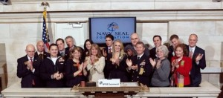
Facebook
Navy SEAL Foundation rings NYSE opening bell
The parents of fallen Navy SEAL Jon Tumilson joined the Navy SEAL Foundation this morning in ringing the opening bell of the New York Stock Exchange.
Tumilson was one of 30 American servicemembers who lost their lives August 6th when Afghan insurgents shot down their Chinook helicopter. A photograph of Tumilson’s dog Hawkeye lying by his master’s coffin went viral and captured the hearts of the countless people who saw it.
The Navy SEAL Foundation rang the opening bell to mark the 5th Annual Navy SEAL Foundation Benefit at the Hilton New York. The benefit takes place tomorrow, December 1st, and will raise money for families of fallen SEALs.

